School of Engineering & Technology

Course Name: Data Analysis and Data visualization

Course Code: 24BEDAS305

Module -1

Topics of Module 1:
1.1 Introduction to Data Analysis: Definition, importance, applications in industry, Structured vs. unstructured data.
1.2 Data Collection & Preprocessing: Importing datasets, Handling missing values, duplicates, and inconsistencies, Feature extraction and selection.
1.3 Introduction to Python for Data Analysis: Overview of NumPy, Pandas, and Matplotlib, Data Frames: Creation, indexing, filtering.

1.1 Introduction to Data Analysis
- Definition:
Data Analysis is the process of inspecting, cleaning, transforming, and modeling data to discover useful information, draw conclusions, and support decision-making.
- Importance of Data Analysis:
Informed Decision-Making: Helps organizations make data-driven decisions.
Identifying Trends and Patterns: Useful for market analysis, forecasting, and strategy building.
Improving Efficiency: Reveals inefficiencies and areas for optimization.
Competitive Advantage: Businesses gain insights into customer behavior and market needs.
Risk Management: Helps identify potential risks and mitigation strategies.
- Applications in Industry:
Healthcare: Predicting disease outbreaks, patient diagnosis, treatment optimization.
Retail & E-commerce: Customer segmentation, inventory management, recommendation systems.
Finance: Fraud detection, credit scoring, investment analysis.
Manufacturing: Predictive maintenance, quality control.
Education: Student performance analysis, curriculum improvements.
Transportation & Logistics: Route optimization, demand forecasting.
Marketing: Campaign analysis, customer feedback analysis.
- Structured vs. Unstructured Data:
Structured Data: Structured data refers to data that is organized in a predefined format, typically in rows and columns, such as in relational databases (like Excel sheets or SQL databases). It is easy to enter, store, query, and analyze using traditional data tools.
- Examples:
  - Customer names and addresses stored in a database
  - Sales records
  - Employee data (ID, salary, department)

Unstructured Data: Unstructured data is not organized in a predefined data model or format. It lacks a consistent structure, making it more difficult to store and analyze using conventional tools.
- Examples:
  - Emails
  - Social media posts
  - Audio and video files
  - Images
  - PDF documents

Feature | Structured Data | Unstructured Data
Format | Predefined (rows & columns) | No fixed format
Storage | Relational Databases (e.g., SQL) | Data lakes, NoSQL, file systems
Examples | Spreadsheets, Customer tables | Emails, Images, Videos, Social media posts
Ease of Analysis | Easy to process and analyze | Requires advanced tools (NLP, ML, etc.)
Tools | SQL, Excel, Power BI | Hadoop, Spark, NLP libraries

1.2 Data Collection & Preprocessing:
- Data Collection: Data Collection is the systematic process of gathering information from various sources to analyse and make decisions. It is an essential part of research, business, and data science projects. Data collection can be done manually or using digital tools, depending on the nature of the study and available resources. The purpose is to obtain accurate and relevant data to answer research questions, identify patterns, or make predictions. The quality of collected data directly impacts the validity of the final results.

- There are two main types of data collection: Primary and Secondary.

Primary data collection involves collecting data directly from original sources through methods like surveys, interviews, observations, and experiments. For example, a researcher conducting a customer satisfaction survey collects primary data.
Secondary data collection involves using existing data that has already been collected by others, such as government reports, academic studies, or online databases. For instance, using data from the Census of India for population analysis is an example of secondary data collection.
- Data preprocessing is the process of preparing raw data for analysis by cleaning and transforming it into a usable format. In data mining it refers to preparing raw data for mining by performing tasks like cleaning, transforming, and organizing it into a format suitable for mining algorithms.

- Goal is to improve the quality of the data.
- Helps in handling missing values, removing duplicates, and normalizing data.
- Ensures the accuracy and consistency of the dataset.

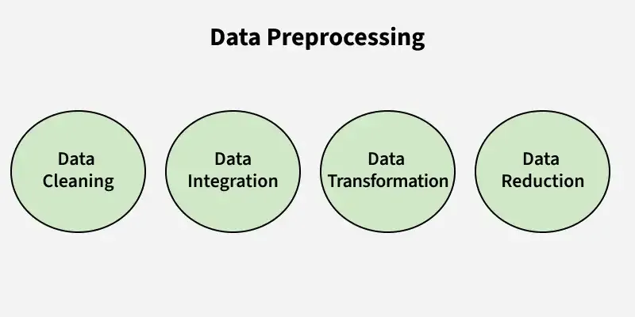

1. Data Cleaning: It is the process of identifying and correcting errors or inconsistencies in the dataset. It involves handling missing values, removing duplicates, and correcting incorrect or outlier data to ensure the dataset is accurate and reliable. Clean data is essential for effective analysis, as it improves the quality of results and enhances the performance of data models.
- Missing Values: This occur when data is absent from a dataset. You can either ignore the rows with missing data or fill the gaps manually, with the attribute mean, or by using the most probable value. This ensures the dataset remains accurate and complete for analysis.
- Noisy Data: It refers to irrelevant or incorrect data that is difficult for machines to interpret, often caused by errors in data collection or entry. It can be handled in several ways:
- Removing Duplicates: It involves identifying and eliminating repeated data entries to ensure accuracy and consistency in the dataset. This process prevents errors and ensures reliable analysis by keeping only unique records.
2. Data Integration: It involves merging data from various sources into a single, unified dataset. It can be challenging due to differences in data formats, structures, and meanings. Techniques like record linkage and data fusion help in combining data efficiently, ensuring consistency and accuracy.
3. Data Transformation: It involves converting data into a format suitable for analysis. Common techniques include normalization, which scales data to a common range; standardization, which adjusts data to have zero mean and unit variance; and discretization, which converts continuous data into discrete categories. These techniques help prepare the data for more accurate analysis.
- Data Normalization: The process of scaling data to a common range to ensure consistency across variables.
- Discretization: Converting continuous data into discrete categories for easier analysis.
- Data Aggregation: Combining multiple data points into a summary form, such as averages or totals, to simplify analysis.
- Concept Hierarchy Generation: Organizing data into a hierarchy of concepts to provide a higher-level view for better understanding and analysis.
4. Data Reduction: It reduces the dataset's size while maintaining key information. This can be done through feature selection, which chooses the most relevant features, and feature extraction, which transforms the data into a lower-dimensional space while preserving important details. It uses various reduction techniques such as,
- Dimensionality Reduction (e.g., Principal Component Analysis): A technique that reduces the number of variables in a dataset while retaining its essential information.
- Numerosity Reduction: Reducing the number of data points by methods like sampling to simplify the dataset without losing critical patterns.
- Data Compression: Reducing the size of data by encoding it in a more compact form, making it easier to store and process.
- Uses of Data Preprocessing
Data preprocessing is utilized across various fields to ensure that raw data is transformed into a usable format for analysis and decision-making.
Here are some key areas where data preprocessing is applied:
1. Data Warehousing: In data warehousing, preprocessing is essential for cleaning, integrating, and structuring data before it is stored in a centralized repository. This ensures the data is consistent and reliable for future queries and reporting.
2. Data Mining: Data preprocessing in data mining involves cleaning and transforming raw data to make it suitable for analysis. This step is crucial for identifying patterns and extracting insights from large datasets.
3. Machine Learning: In machine learning, preprocessing prepares raw data for model training. This includes handling missing values, normalizing features, encoding categorical variables, and splitting datasets into training and testing sets to improve model performance and accuracy.
4. Data Science: Data preprocessing is a fundamental step in data science projects, ensuring that the data used for analysis or building predictive models is clean, structured, and relevant. It enhances the overall quality of insights derived from the data.
5. Web Mining: In web mining, preprocessing helps analyze web usage logs to extract meaningful user behavior patterns. This can inform marketing strategies and improve user experience through personalized recommendations.
6. Business Intelligence (BI): Preprocessing supports BI by organizing and cleaning data to create dashboards and reports that provide actionable insights for decision-makers.
7. Deep Learning Purpose: Similar to machine learning, deep learning applications require preprocessing to normalize or enhance features of the input data, optimizing model training processes.

Advantages of Data Preprocessing
- Improved Data Quality: Ensures data is clean, consistent, and reliable for analysis.
- Better Model Performance: Reduces noise and irrelevant data, leading to more accurate predictions and insights.
- Efficient Data Analysis: Streamlines data for faster and easier processing.
- Enhanced Decision-Making: Provides clear and well-organized data for better business decisions.
Disadvantages of Data Preprocessing
- Time-Consuming: Requires significant time and effort to clean, transform, and organize data.
- Resource-Intensive: Demands computational power and skilled personnel for complex preprocessing tasks.
- Potential Data Loss: Incorrect handling may result in losing valuable information.
- Complexity: Handling large datasets or diverse formats can be challenging.
1. Importing Datasets
Importing datasets is the first and essential step in data analysis or machine learning. It involves loading data from various sources into a programming environment like Python or R.
🔹 Data Formats:
- CSV (Comma-Separated Values) – Most common; easy to read and edit.
- Excel (.xlsx) – Widely used in business.
- JSON (JavaScript Object Notation) – Used for structured data exchange.
- SQL Databases – Used when data is stored in relational databases.
- Text Files – For unstructured or semi-structured data.
🔹 Tools for Importing in Python (using pandas):
- pd.read_csv('file.csv') – For CSV files
- pd.read_excel('file.xlsx') – For Excel files
- pd.read_json('file.json') – For JSON data
- pd.read_sql(query, connection) – From databases
🔹 Sources of Data:
- Local files – Stored on your computer
- URLs – Download data directly from the internet
- APIs – Access real-time data from services (e.g., Twitter API)
- Cloud storage – AWS S3, Google Drive, etc.

2. Handling Missing Values, Duplicates, and Inconsistencies
Data collected from real-world sources is often dirty – it may contain missing values, duplicates, or inconsistent entries. Cleaning this data is vital for accurate analysis.
🔸 a. Handling Missing Values
🔍 Causes:
- Human error in data entry
- Data not available or skipped
- Corrupted files
🛠 Detection:
- Python: df.isnull().sum()
💡 Strategies:
- Drop missing data:
  - df.dropna() – Removes rows with missing values
  - Use when missing data is minimal and dropping it doesn’t affect analysis.
- Impute missing data:
  - Numerical data: Fill with mean, median, or mode

df['age'].fillna(df['age'].mean(), inplace=True)
or
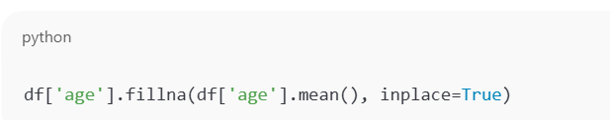

Categorical data: Fill with mode or use placeholder like “Unknown”
Advanced methods:
- Interpolation
- K-Nearest Neighbors (KNN)
- Predictive models (regression, decision trees)

b. Handling Duplicates
🔍 Problem:
- Duplicated rows can mislead summary statistics or model training.
🛠 Detection:
- df.duplicated() – Returns Boolean Series
- df[df.duplicated()] – Shows duplicate rows
✅ Handling:
- Remove using: df.drop_duplicates(inplace=True)
c. Handling Inconsistencies
🔍 Common issues:
- Typos (e.g., “Male”, “male”, “MALE” treated differently)
- Different formats (e.g., "2025/08/07" vs. "07-08-2025")
- Incorrect labeling (e.g., "Na" for both Sodium and Null)
🛠 Solutions:
- Standardize formats (e.g., .str.lower(), .str.strip())
- Use consistent data types (e.g., pd.to_datetime())
- Replace incorrect entries with correct ones:
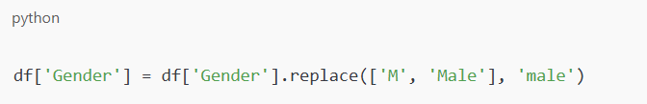

3. Feature Extraction and Selection
This step transforms raw data into meaningful features that can improve model accuracy and performance.
🔸 a. Feature Extraction
Feature extraction is the process of deriving new features from existing data.
📌 Examples:
- From a date column, extract: Year, Month, Day, Weekday
- From a text column, extract: Word count, sentiment, keywords
- From timestamps, extract: Time of day, duration

- Techniques:
- Text Data:
  - Bag of Words
  - TF-IDF (Term Frequency-Inverse Document Frequency)
  - Word Embeddings (Word2Vec, GloVe)
- Image/Audio Data:
  - Pixel intensities
  - Frequency components (e.g., using Fourier transform)

🔸 b. Feature Selection
Feature selection involves choosing the most relevant features for training the model. It helps in reducing overfitting, improving accuracy, and decreasing computation time.
✅ Benefits:
- Improves model performance
- Reduces complexity
- Prevents overfitting
- Methods:
Method Type | Techniques | Description
Filter | Correlation, Chi-square, ANOVA | Evaluate feature importance independently
Wrapper | Recursive Feature Elimination (RFE) | Uses model performance to select features
Embedded | LASSO (L1), Tree-based methods | Feature selection built into m

Summary:

- Importing Datasets
- Choose Appropriate Libraries:
Use libraries like Pandas in Python for efficient data loading and manipulation.
- Specify File Paths and Formats:
Provide the correct path to your data file (e.g., CSV, Excel, JSON) and specify the format.
- Handle Delimiters and Headers:
Ensure correct delimiters are used for text-based files and identify if a header row exists.
- Manage Data Types:
Explicitly define or allow the library to infer appropriate data types for each column to prevent errors during analysis.
Handling Missing Values
- Identify Missing Values:
Detect missing data, often represented as NaN, None, or specific sentinel values.
- Understand Missingness Mechanisms:
Consider why data is missing (e.g., Missing Completely At Random, Missing At Random, Missing Not At Random) as this influences the imputation strategy.
- Imputation Techniques:
  - Deletion: Remove rows or columns with missing values (use cautiously to avoid data loss).
  - Mean/Median/Mode Imputation: Replace missing values with the mean, median, or mode of the respective column.
  - Forward/Backward Fill: Propagate the last/next valid observation forward/backward, useful for time-series data.
  - Advanced Imputation: Utilize more sophisticated methods like K-Nearest Neighbors (KNN) imputation or regression imputation for better accuracy.
- Handling Duplicates
- Identify Duplicate Rows: Detect rows that are identical across all or a subset of columns.
- Remove Duplicates: Delete duplicate rows to ensure each observation is unique, preventing biased analysis.
- Consider Subset Duplicates: In some cases, only a subset of columns might define a unique record, requiring specific handling.
Handling Inconsistencies
- Standardize Data Formats:
Ensure consistent formatting for dates, categories, and numerical values (e.g., "USA" vs. "United States").
- Correct Typos and Misspellings:
Address inconsistencies arising from human error in data entry.
- Resolve Contradictory Data:
Identify and resolve conflicting information within or across columns (e.g., age and birthdate mismatch).
- Handle Outliers:
Investigate extreme values that might be data entry errors or genuine outliers requiring special consideration or transformation.
- Address Structural Errors:
Correct issues like incorrect column headers or merged cells that disrupt data structure.
- Methods for Identifying Missing Data
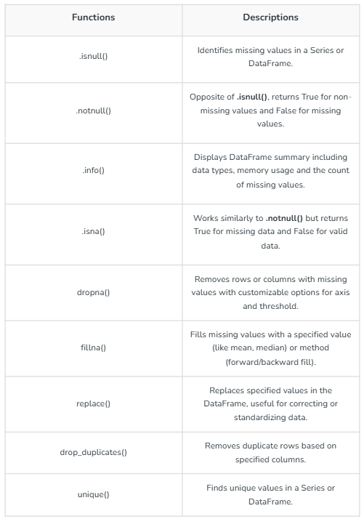

- Feature Extraction and Selection – Basics
1. Introduction
- Features are the measurable properties or characteristics of your data that a machine learning model uses to make predictions.
- Good features help the model learn patterns better.
- Two main approaches to improve features:
  - Feature Extraction – Creating new features from raw data.
  - Feature Selection – Choosing the most useful features.

2. Feature Extraction
- Definition: Process of transforming raw data into informative features for analysis.
- Purpose: Reduce complexity, improve model performance, and make data more interpretable.
- Examples:
  - From text → Count of words, TF-IDF scores.
  - From images → Edges, shapes, color histograms.
  - From time series → Mean, variance, peak values.
- Methods:
  - Principal Component Analysis (PCA) – Reduces dimensions by finding main patterns.
  - Fourier Transform – Extracts frequency information (common in signal processing).
  - Convolution filters – Extract patterns from images.

3. Feature Selection
- Definition: Process of picking only the most relevant features from the dataset.
- Purpose:
  - Remove irrelevant/noisy features.
  - Avoid overfitting.
  - Reduce computation time.
- Types:
  - Filter Methods – Select features based on statistical measures (e.g., correlation, Chi-square test).
  - Wrapper Methods – Use a model to test feature combinations (e.g., forward/backward selection).
  - Embedded Methods – Feature selection happens during model training (e.g., Lasso regression, decision tree feature importance).

4. Why It’s Important
- Better Accuracy – Focus on useful data.
- Faster Training – Less data to process.
- Simpler Models – Easier to interpret.

5. Simple Example
Imagine you’re predicting house prices:
- Feature Extraction: From “Date Built” → Create “House Age”.
- Feature Selection: Keep “Number of Rooms” and “Location” but drop “Paint Color”.

✅ Tip for Beginners:
Start with feature selection to remove unnecessary columns, then use feature extraction to create better features from existing ones.

Raw Data → Extraction → Selection → Final Features → Model

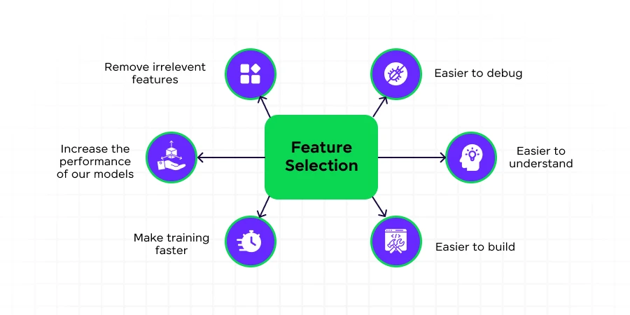

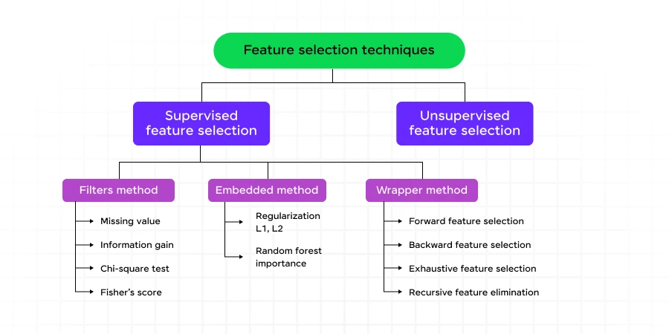

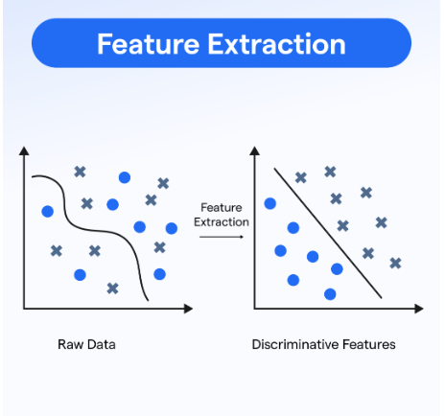

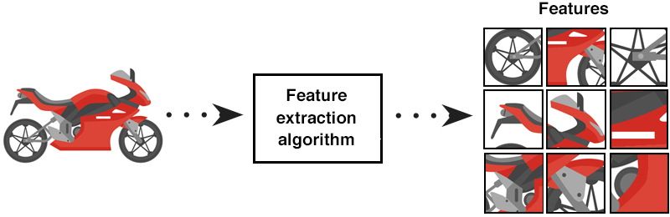

1.3 Introduction to Python for Data Analysis
Python is a powerful, easy-to-learn programming language widely used in data science and analytics. It supports a large ecosystem of libraries specifically designed for data manipulation, analysis, and visualization. The most commonly used libraries include:
- NumPy for numerical operations
- Pandas for data manipulation and analysis
- Matplotlib for data visualization
🔢 NumPy (Numerical Python)
What is NumPy?
NumPy is the foundational package for numerical computing in Python. It introduces the ndarray object (N-dimensional array), which is more efficient and faster than native Python lists.
- NumPy for (Data Analysis & Visualization)
1. Introduction to NumPy
- Full form: Numerical Python
- Purpose: A Python library for fast mathematical computations and handling large multi-dimensional arrays.
- Key advantages:
  - Faster than Python lists (uses C language under the hood)
  - Convenient array manipulation
  - Integrated with many data science libraries (Pandas, Matplotlib, SciPy, etc.)

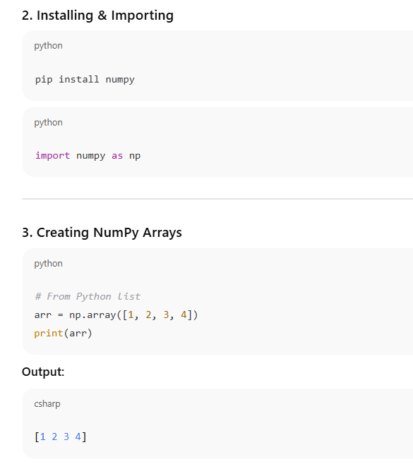
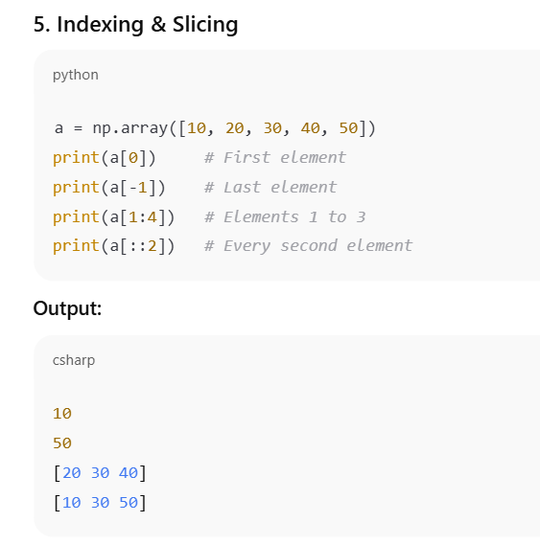

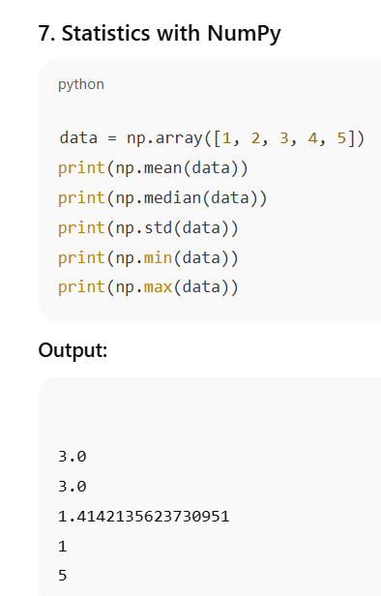

- 📊 Pandas (Python Data Analysis Library)
What is Pandas?
Pandas is a high-level library that provides data structures like Series (1D) and DataFrame (2D), designed for working with structured data.
Key Features:
- Easy handling of missing data
- Data alignment and reshaping
- Grouping, merging, and joining datasets
- Time-series analysis
Importing:


📑 DataFrames in Pandas
1. Creation of DataFrame
A DataFrame can be created from:
- Lists
- Dictionaries
- NumPy arrays
- CSV/Excel files, etc.
Example 1:
- Create a simple Pandas DataFrame:

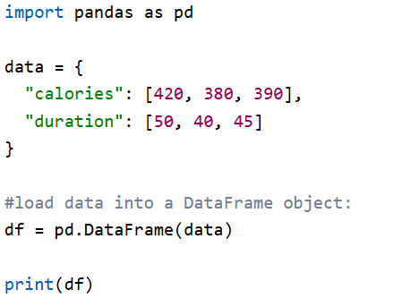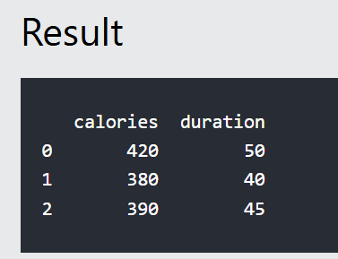

- Named Indexes

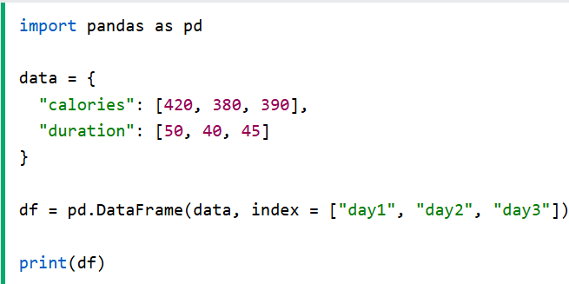

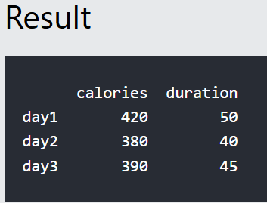

2. Indexing in DataFrame
There are two main indexing methods:
a. Label-based indexing (.loc)

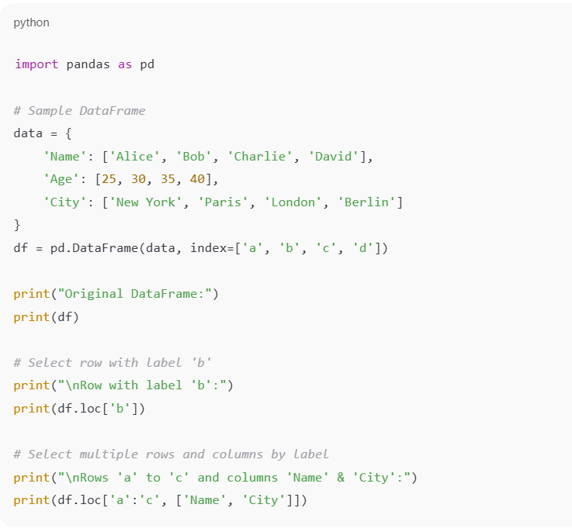
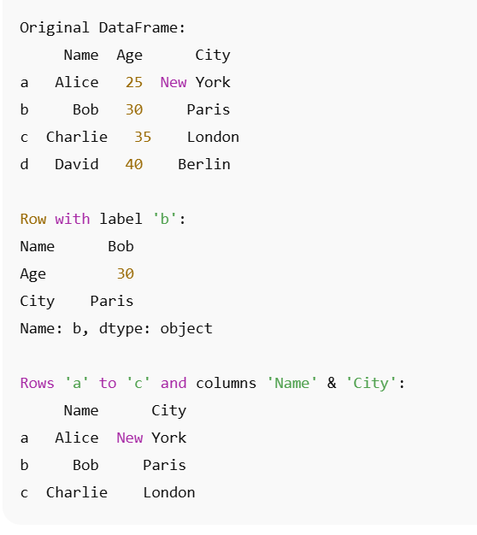
  - Position-based Indexing → .iloc[]
• Uses row and column positions (numbers).
• Think of it like list indexing in Python.

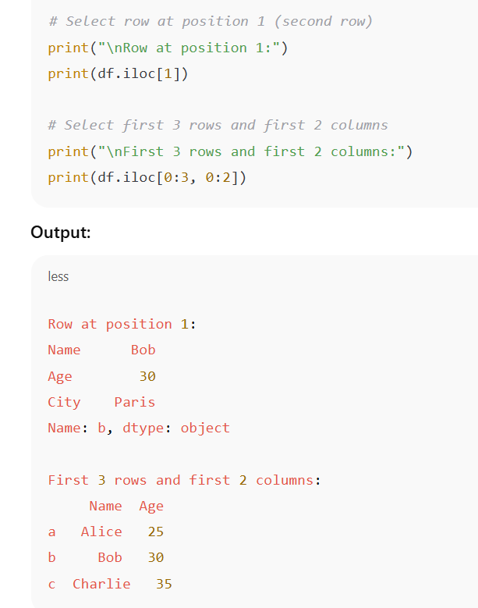

3. Filtering DataFrames
Filtering is used to extract rows that meet certain conditions.
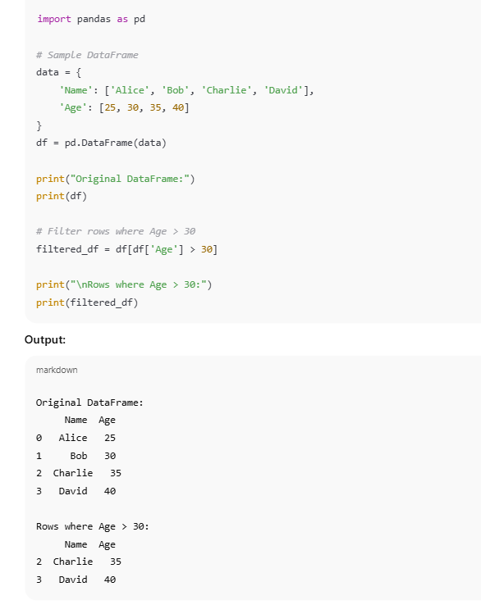

📈 Matplotlib (Data Visualization)
What is Matplotlib?
Matplotlib is a 2D plotting library for creating static, animated, and interactive visualizations.
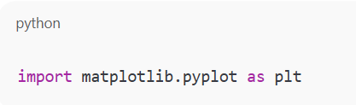

Basic Plot Types:
- Line Plot: plt.plot(x, y)
- Bar Chart: plt.bar(x, height)
- Histogram: plt.hist(data)
- Scatter Plot: plt.scatter(x, y)
Example:
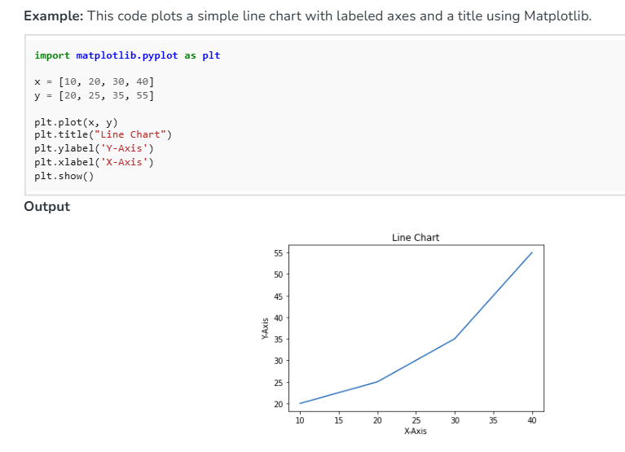

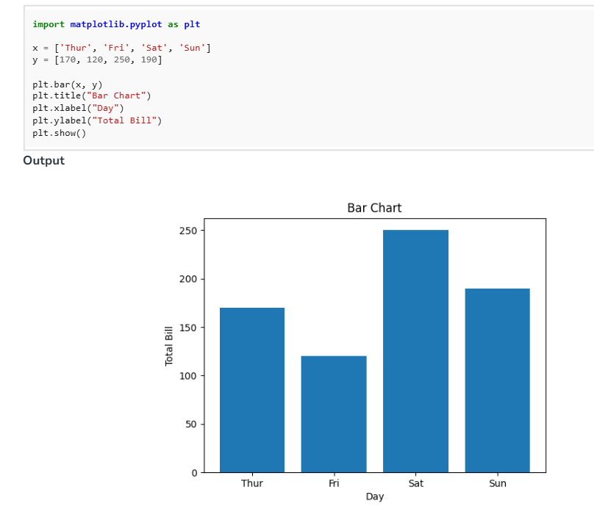

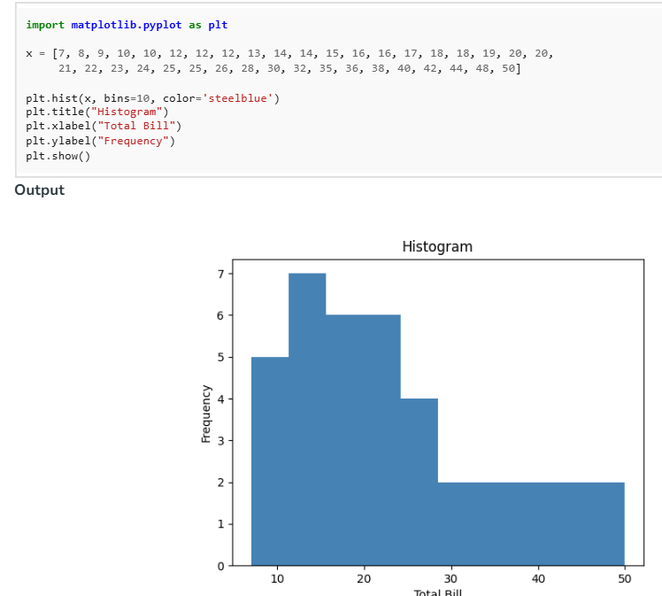

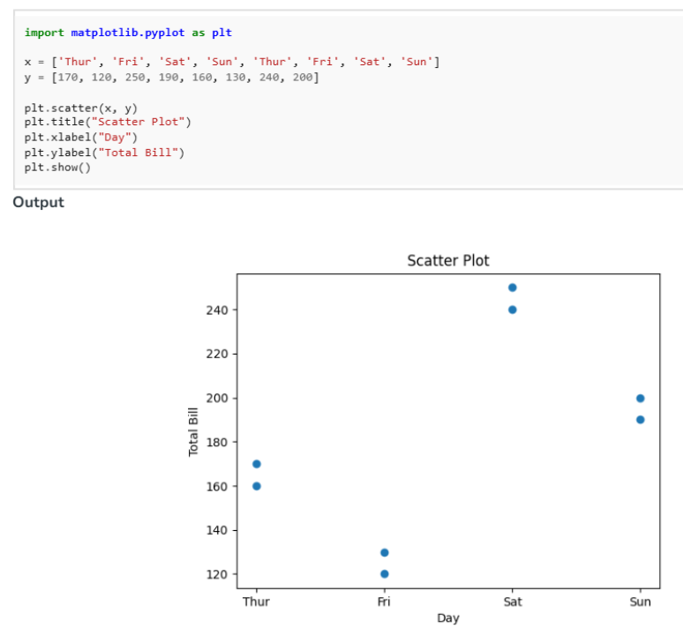
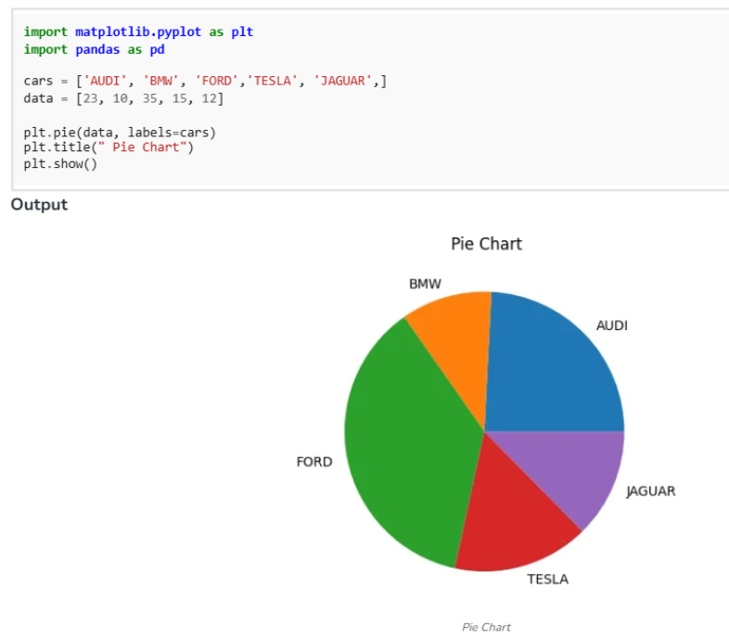

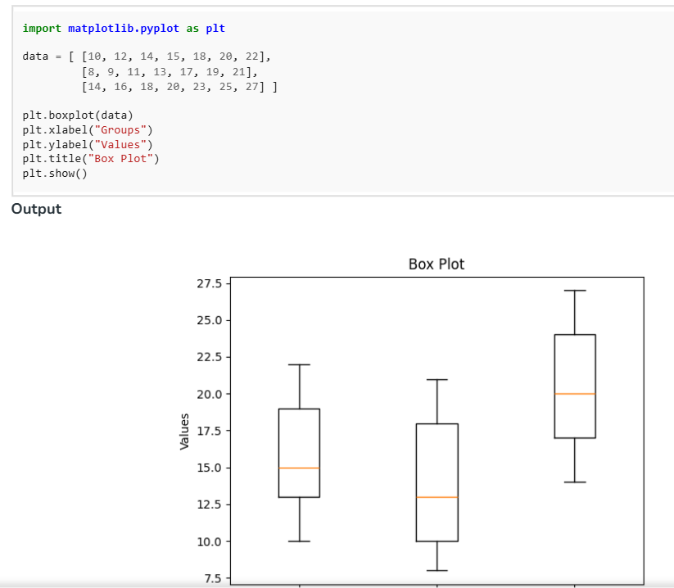

Summary
Library | Purpose | Core Object
NumPy | Numerical operations, arrays | ndarray
Pandas | Data manipulation, analysis | DataFrame, Series
Matplotlib | Visualization | Plots, Charts

Websites for studying Basic/Beginner level capstone projects:Kaggle and GitHub is a web-based platform

